1. **OVERVIEW**

In this section, we provide a comprehensive overview of the CryptoChecker project, detailing its objectives and key features.

**1.1 Objectives**

The primary objectives of the CryptoChecker project are multifaceted, aiming to address the growing need for robust cryptocurrency tracking and analysis tools in today's dynamic financial landscape. These objectives include:

1. **Real-Time Data Tracking:** To develop a platform capable of aggregating and displaying real-time data from multiple cryptocurrency exchanges, allowing users to monitor market trends, price fluctuations, and trading volumes instantaneously.
2. **Comprehensive Analysis:** To empower users with advanced analytical capabilities, including technical analysis indicators, historical price data, and sentiment analysis tools, enabling them to make informed investment decisions.
3. **User-Friendly Interface:** To design an intuitive and user-friendly interface that caters to both novice and experienced cryptocurrency enthusiasts, ensuring ease of navigation, accessibility, and customization.
4. **Portfolio Management:** To incorporate portfolio management features, allowing users to track their cryptocurrency holdings, view portfolio performance metrics, and execute trades directly within the platform.
5. **Integration with External APIs:** To seamlessly integrate with external APIs and data sources, enabling access to a wide range of cryptocurrency data, news feeds, and market insights to enrich the user experience.
6. **Security and Reliability:** To prioritize security and reliability in all aspects of the application, implementing robust encryption protocols, authentication mechanisms, and data integrity checks to safeguard user information and transactions.
7. **Scalability and Flexibility:** To build a scalable and flexible architecture that can accommodate future growth and expansion, supporting additional features, cryptocurrencies, and user functionalities as the platform evolves.

**1.2 Key Features**

The CryptoChecker application boasts a plethora of key features designed to meet the diverse needs of cryptocurrency investors, traders, and enthusiasts. Some of the standout features include:

1. **Live Market Data:** Access real-time price data, trading volumes, and market capitalizations for thousands of cryptocurrencies across multiple exchanges.
2. **Interactive Charts:** Utilize interactive charts and graphs to visualize historical price data, technical indicators, and trading patterns, allowing for in-depth analysis and decision-making.
3. **Customizable Dashboards:** Personalize your dashboard with widgets, watchlists, and performance metrics tailored to your investment preferences and trading strategies.
4. **Portfolio Tracking:** Track the performance of your cryptocurrency portfolio in real-time, including holdings, gains/losses, asset allocation, and transaction history.
5. **Alerts and Notifications:** Set custom alerts and notifications for price movements, volume spikes, and news events, ensuring you never miss out on important market developments.
6. **News and Insights:** Stay informed with the latest cryptocurrency news, analysis, and insights curated from trusted sources, helping you stay ahead of market trends and developments.
7. **Secure Transactions:** Execute trades and transactions securely within the platform, with built-in encryption, two-factor authentication, and secure wallet integrations to protect your assets.
8. **Community Engagement:** Engage with a vibrant community of cryptocurrency enthusiasts, traders, and experts, sharing insights, strategies, and trading tips in real-time.
9. **Cross-Platform Compatibility:** Access CryptoChecker from any device, including desktops, laptops, smartphones, and tablets, with seamless synchronization of data and settings across multiple devices.
10. **Continuous Updates:** Benefit from regular updates and enhancements to the CryptoChecker platform, including new features, performance improvements, and bug fixes based on user feedback and market trends.

**2. INTRODUCTION**

**2.1 Context for the Project**

The context for the CryptoChecker project lies within the dynamic and evolving landscape of cryptocurrencies. Over the past decade, cryptocurrencies have emerged as a disruptive force in the financial world, challenging traditional notions of currency and investment. As digital assets that operate on decentralized networks using blockchain technology, cryptocurrencies offer unique advantages such as transparency, security, and accessibility. However, their volatile nature and complex market dynamics present significant challenges for investors, traders, and enthusiasts.

The rapid proliferation of cryptocurrencies has led to an explosion of data, with thousands of digital assets traded on various exchanges worldwide. This abundance of data, coupled with the fast-paced nature of cryptocurrency markets, creates a pressing need for robust tracking and analysis tools. Investors and traders require comprehensive solutions to monitor market trends, track portfolio performance, and make informed decisions in real-time.

Against this backdrop, the CryptoChecker project emerges as a response to the growing demand for sophisticated cryptocurrency tracking and analysis tools. By leveraging advanced technologies and data analytics techniques, CryptoChecker aims to empower users with actionable insights and comprehensive data visualization capabilities. The project seeks to bridge the gap between complex cryptocurrency data and end-users, enabling them to navigate the digital asset landscape with confidence and efficiency.

**2.2 Need for Cryptocurrency Tracking and Analysis Tools**

The need for cryptocurrency tracking and analysis tools stems from the unique characteristics of digital assets and the challenges they pose to market participants. Unlike traditional financial instruments, cryptocurrencies operate in a decentralized and largely unregulated environment, characterized by high volatility and rapid price fluctuations. As a result, investors and traders face considerable uncertainty and risk when navigating cryptocurrency markets.

Effective tracking and analysis tools are essential for mitigating these risks and maximizing opportunities in the cryptocurrency space. Such tools provide users with real-time access to market data, allowing them to monitor price movements, trading volumes, and other key metrics across multiple exchanges and digital assets. By aggregating and analyzing vast amounts of data, these tools enable users to identify trends, patterns, and anomalies in cryptocurrency markets, facilitating informed decision-making and strategic planning.

Moreover, cryptocurrency tracking and analysis tools play a crucial role in portfolio management and risk assessment. Investors rely on these tools to track the performance of their cryptocurrency holdings, assess portfolio diversification, and manage exposure to various assets and market segments. By providing comprehensive portfolio management features, including asset allocation, performance tracking, and risk analysis, these tools empower users to optimize their investment strategies and achieve their financial goals.

In addition to investors and traders, cryptocurrency tracking and analysis tools cater to a broader audience, including researchers, analysts, and enthusiasts. These tools serve as valuable resources for conducting market research, analyzing historical data, and gaining insights into emerging trends and developments in the cryptocurrency ecosystem. By democratizing access to cryptocurrency data and analysis tools, these platforms contribute to the democratization of finance and promote greater transparency and inclusivity in the digital asset space.

**2.3 Overview of CryptoChecker Application**

The CryptoChecker application is a comprehensive cryptocurrency tracking and analysis platform designed to meet the diverse needs of investors, traders, and enthusiasts. At its core, CryptoChecker combines cutting-edge technology with intuitive design to deliver a seamless and user-friendly experience. The application offers a wide range of features and functionalities, including real-time market data, customizable charts and graphs, portfolio management tools, and advanced analytics capabilities.

One of the key highlights of the CryptoChecker application is its real-time market data feed, which provides users with up-to-date information on cryptocurrency prices, trading volumes, and market trends. Through an intuitive dashboard interface, users can access a curated selection of cryptocurrencies and exchanges, allowing them to monitor their favorite assets and stay informed about market developments.

In addition to real-time market data, CryptoChecker offers a suite of powerful charting and visualization tools that enable users to analyze cryptocurrency data in-depth. From simple line charts to advanced candlestick patterns, users can customize their charts to visualize price movements, trading patterns, and technical indicators. These visualizations empower users to gain insights into market trends, identify trading opportunities, and make informed decisions.

Furthermore, CryptoChecker provides comprehensive portfolio management tools that allow users to track their cryptocurrency holdings, monitor portfolio performance, and analyze investment strategies. Users can create custom portfolios, track their asset allocations, and generate performance reports to evaluate their investment performance over time. Additionally, CryptoChecker offers risk management features, including portfolio diversification analysis and volatility tracking, to help users manage their investment risk effectively.

Overall, CryptoChecker aims to be the ultimate companion for cryptocurrency enthusiasts, providing them with the tools and insights they need to navigate the complex world of digital assets with confidence and ease. Whether you're a seasoned trader, a long-term investor, or simply curious about cryptocurrencies, CryptoChecker has something to offer for everyone.

**3. SAMPLE CODE**

* 1. **Excerpts of Code Snippets from Key Components**

Below are excerpts of code snippets from key components of the CryptoChecker application, providing insight into the underlying implementation:

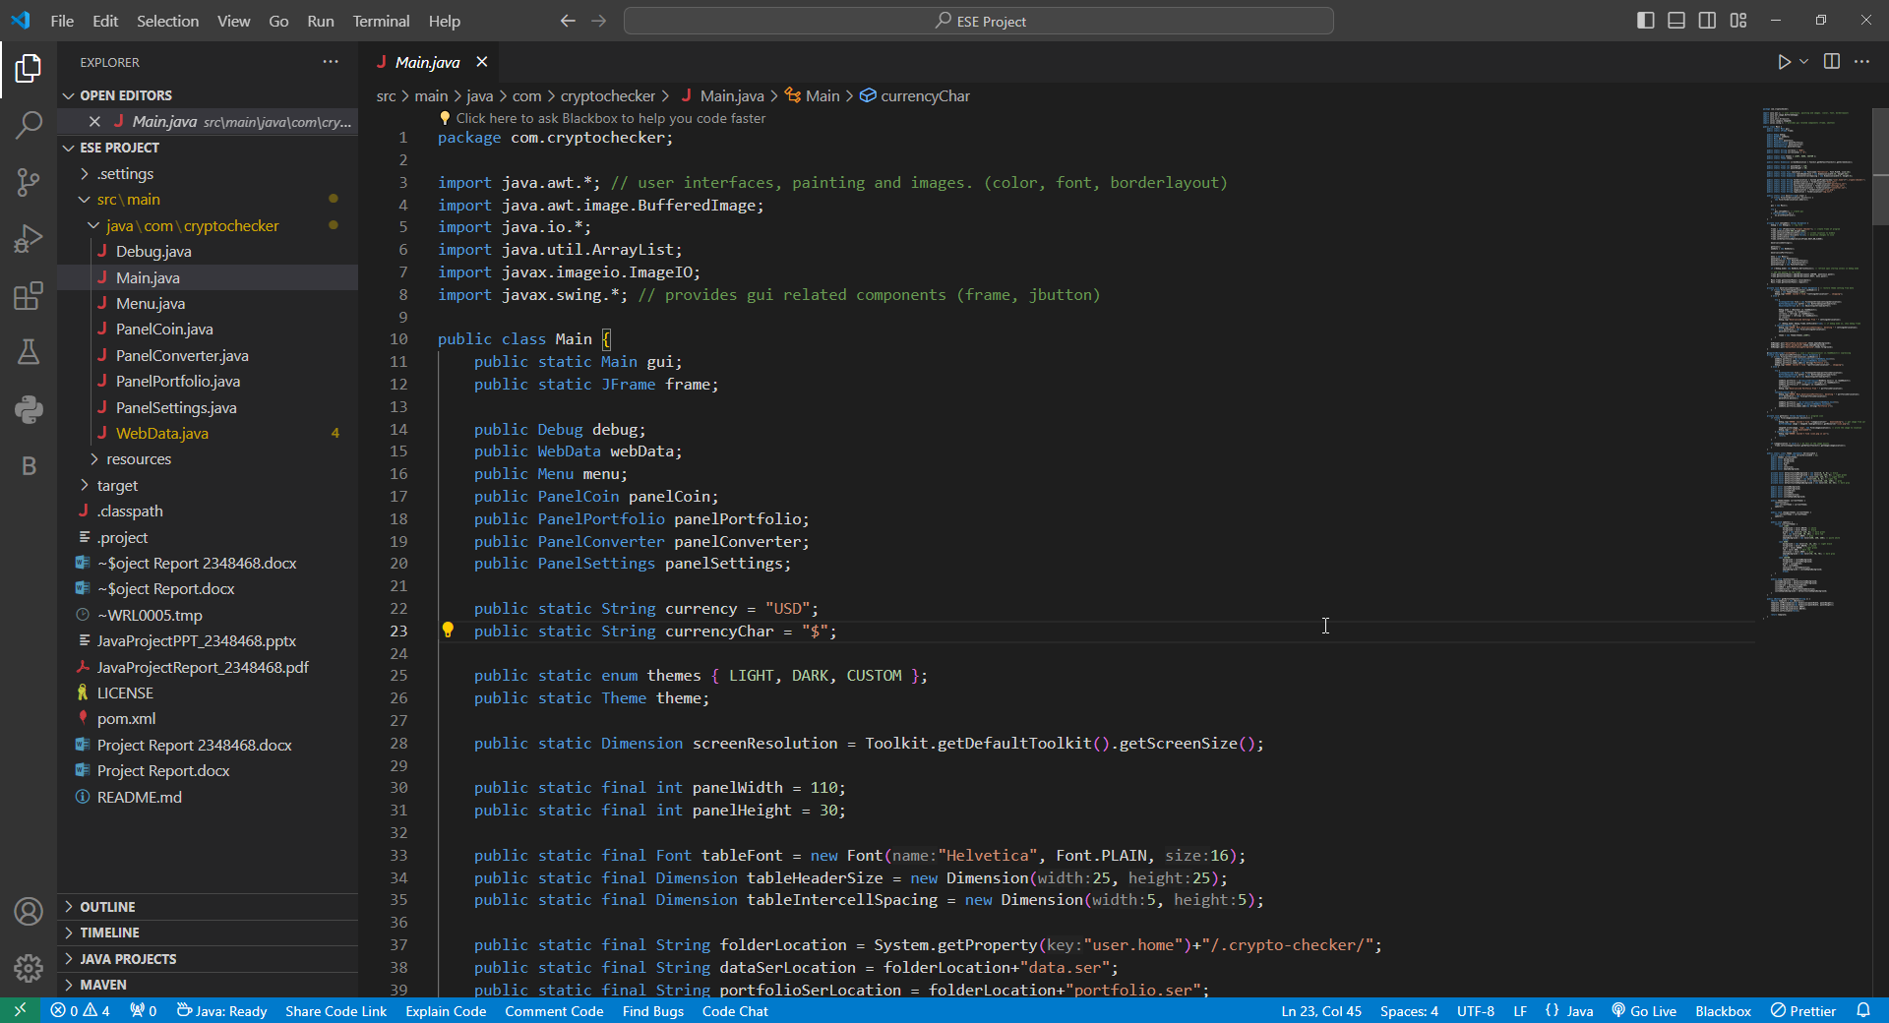

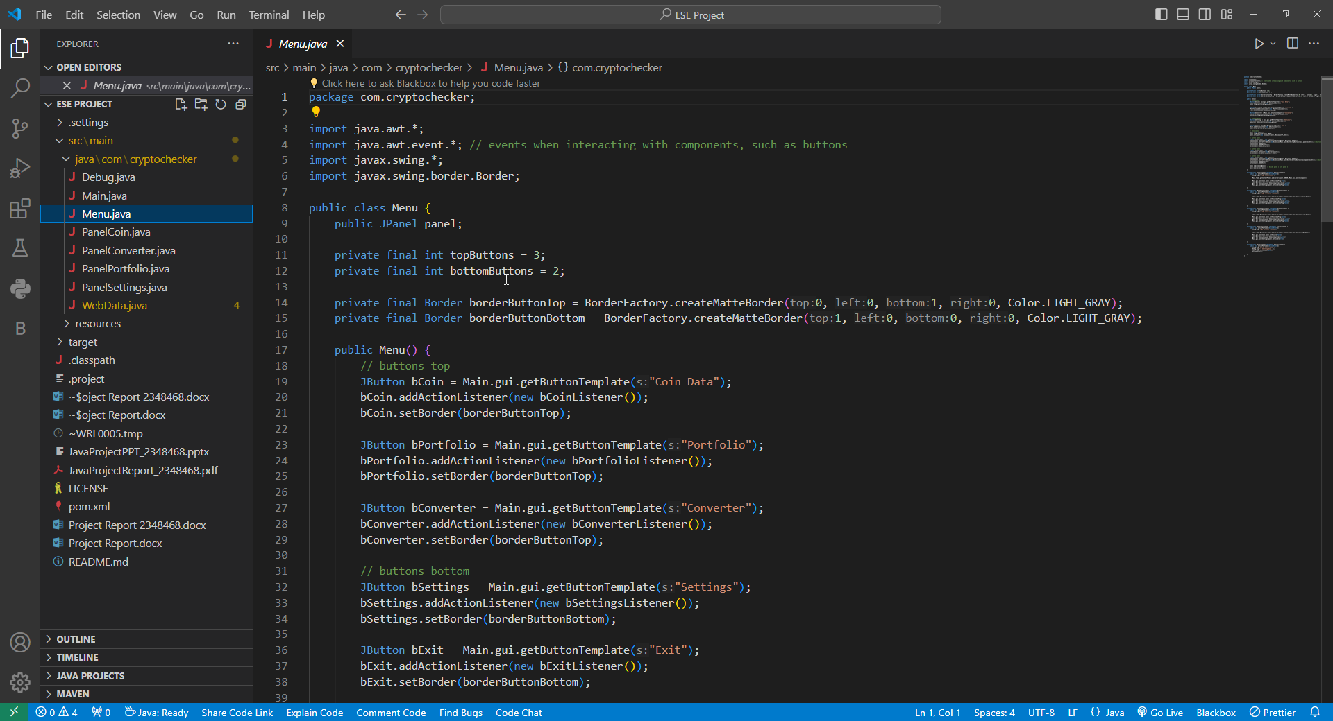

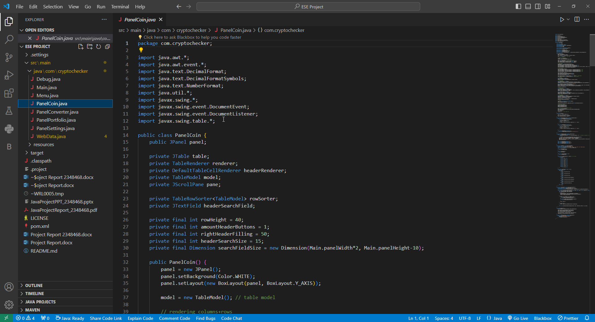

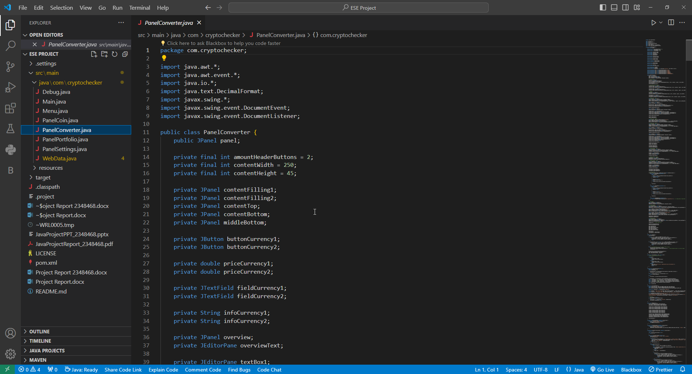

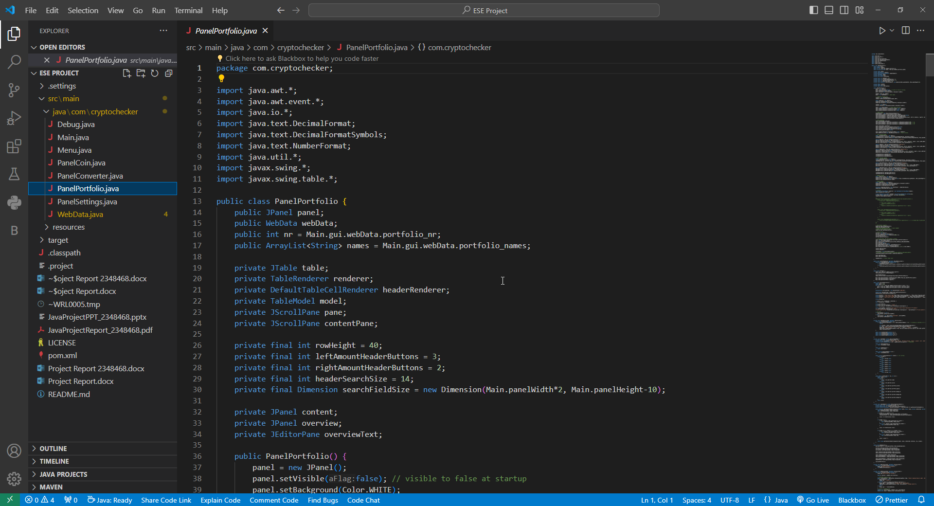

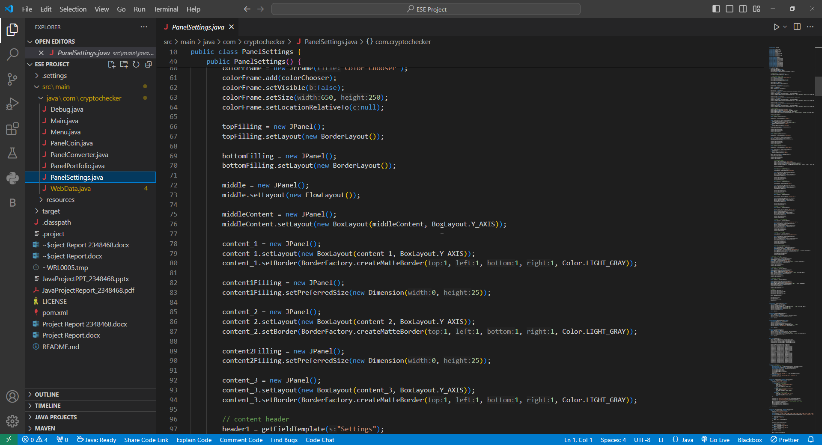

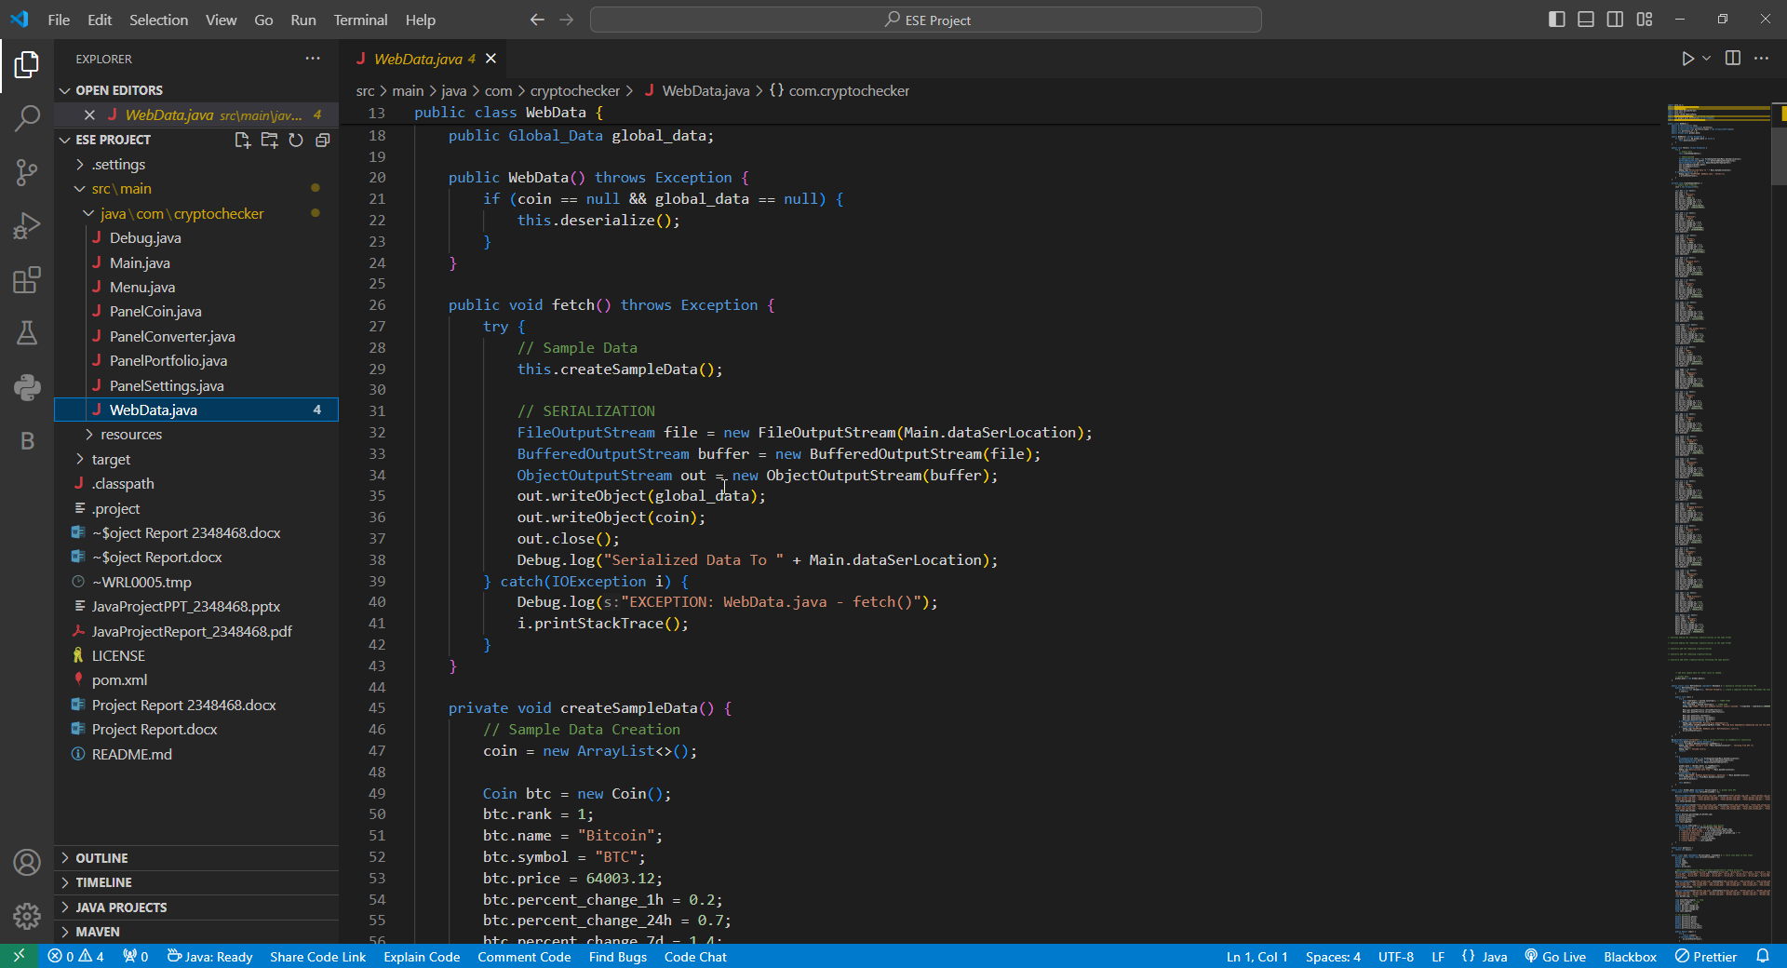

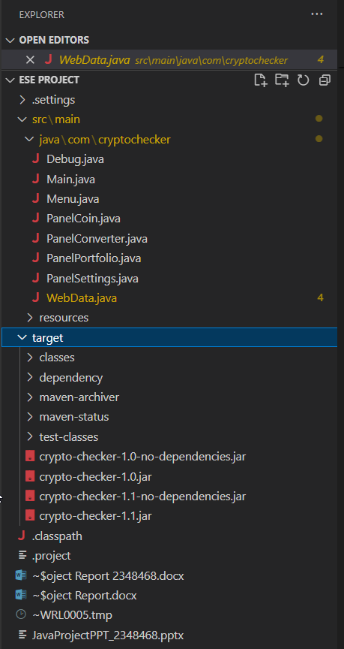

* 1. **Illustrative Examples of Implementation Details**

To provide a deeper understanding of the CryptoChecker application's implementation details, let's consider the following illustrative examples:]

* Customizable Chart Components: Users can customize chart components such as colors, line styles, and data markers to enhance the visual representation of cryptocurrency data. For example, they can choose different color schemes for bullish and bearish price movements or adjust the thickness of trend lines for technical analysis.
* Dynamic Data Fetching: The application employs dynamic data fetching mechanisms to ensure real-time updates of cryptocurrency prices and market data. By periodically polling cryptocurrency exchanges and data APIs, the application retrieves the latest market information and updates the user interface accordingly.
* Responsive User Interface: The user interface of the CryptoChecker application is designed to be responsive and interactive, providing users with a smooth and seamless experience across different devices and screen sizes. The application utilizes layout managers and responsive design techniques to adapt to changes in screen resolution and orientation.
* Offline Data Storage: To improve performance and reliability, the application incorporates offline data storage mechanisms to cache cryptocurrency data locally. By storing historical price data and market trends offline, the application reduces reliance on external APIs and enhances user experience, especially in low-bandwidth or offline scenarios.
* Advanced Data Analysis: The application utilizes advanced data analysis algorithms and techniques to identify patterns, trends, and anomalies in cryptocurrency data. From simple moving averages to complex machine learning models, the application offers a range of analytical tools to help users make informed investment decisions and strategic choices.
* Security and Privacy Features: Given the sensitive nature of financial data, the application prioritizes security and privacy features to protect user information and assets. It implements encryption, authentication, and access control mechanisms to safeguard user data and prevent unauthorized access or tampering.

These illustrative examples highlight the diverse range of implementation details and technical considerations involved in developing the CryptoChecker application. By combining robust code architecture with user-centric design principles, the application aims to deliver a powerful yet intuitive cryptocurrency tracking and analysis platform for users of all levels.

1. **OUTPUT**
   1. **Screenshots of the Application's User Interface**

Below are screenshots showcasing various aspects of the CryptoChecker application's user interface, providing a visual representation of its features and functionalities.

The dashboard provides an overview of the user's cryptocurrency portfolio, including total portfolio value, asset allocation, and recent price trends. Users can customize the dashboard layout and widgets according to their preferences.

The price chart displays historical price data for selected cryptocurrencies, allowing users to visualize price movements over different time periods. Users can zoom in/out, scroll, and analyze price trends using technical indicators and drawing tools.

The portfolio management interface enables users to track their cryptocurrency holdings, including quantity, cost basis, and current market value. Users can add/remove assets, set price alerts, and analyze portfolio performance using interactive charts and reports.

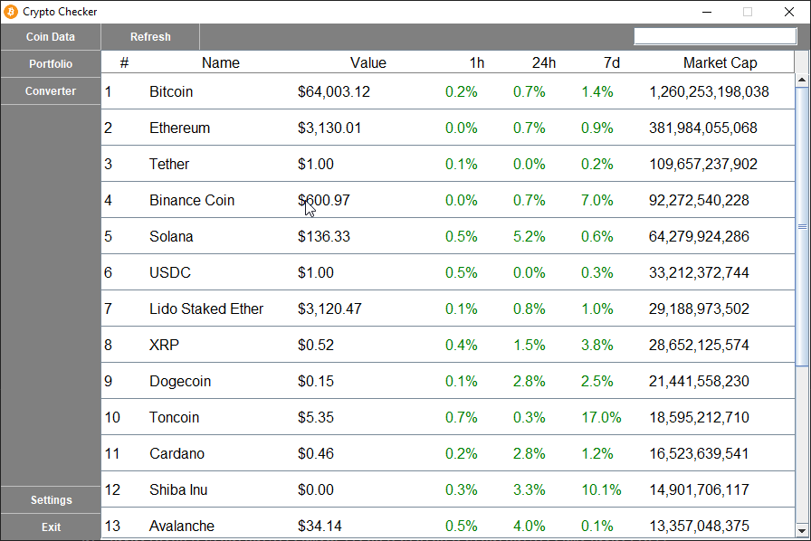

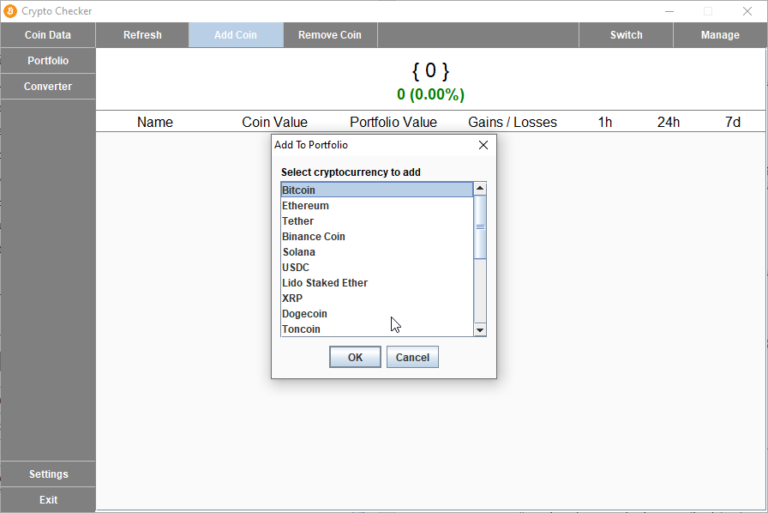

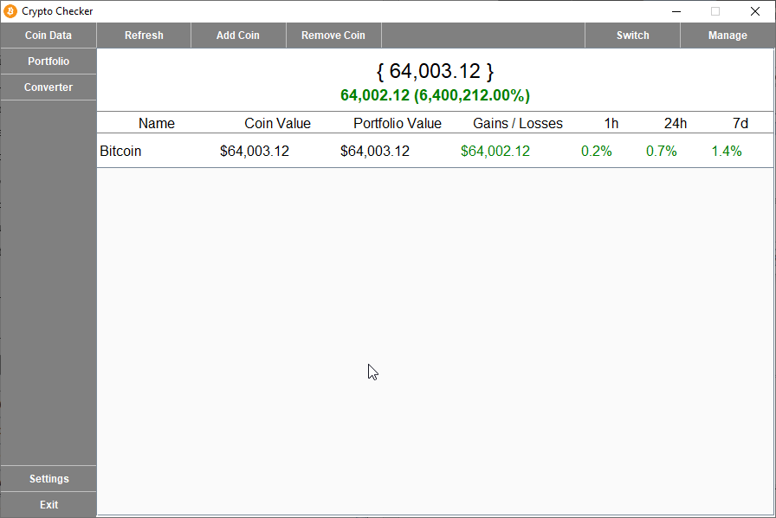

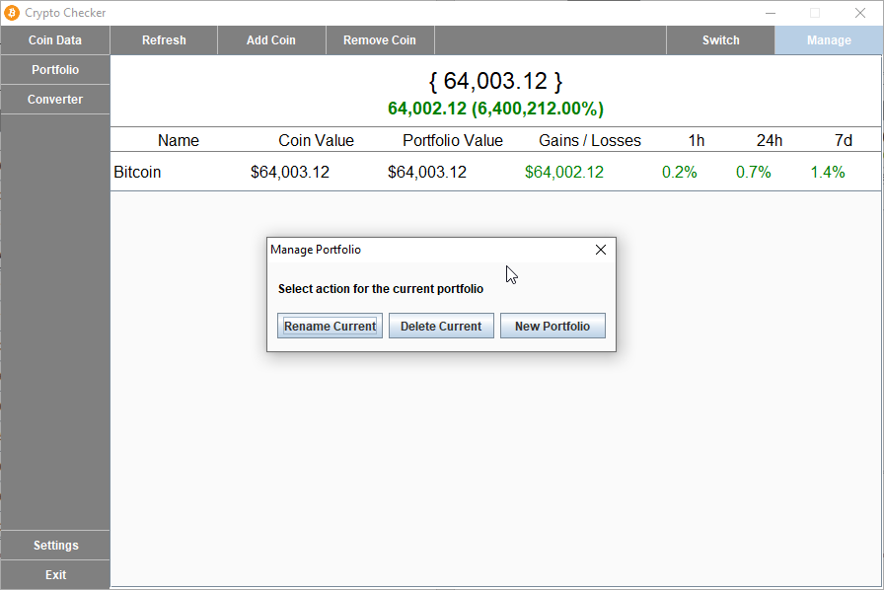

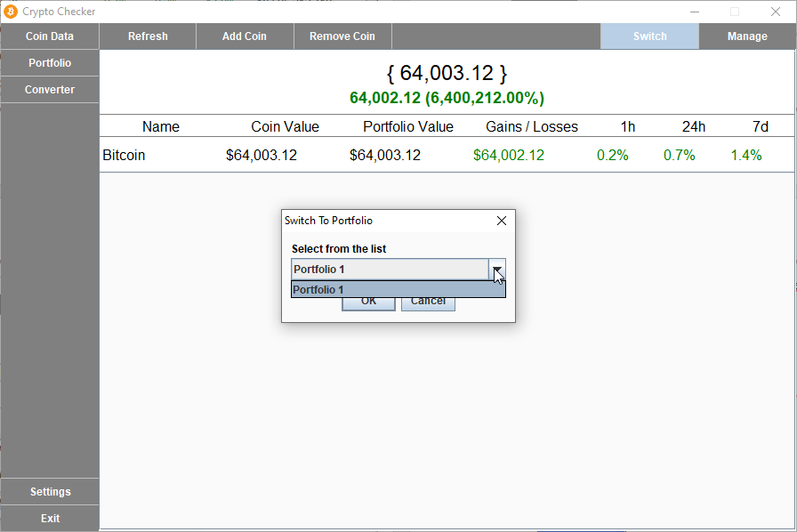

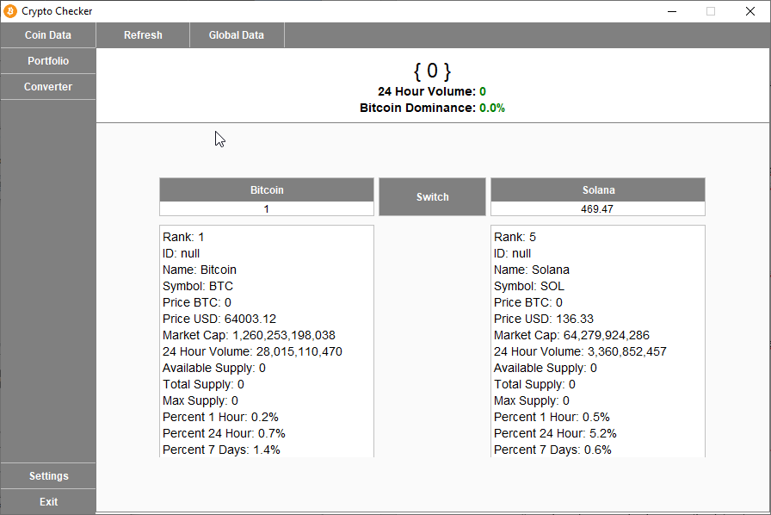

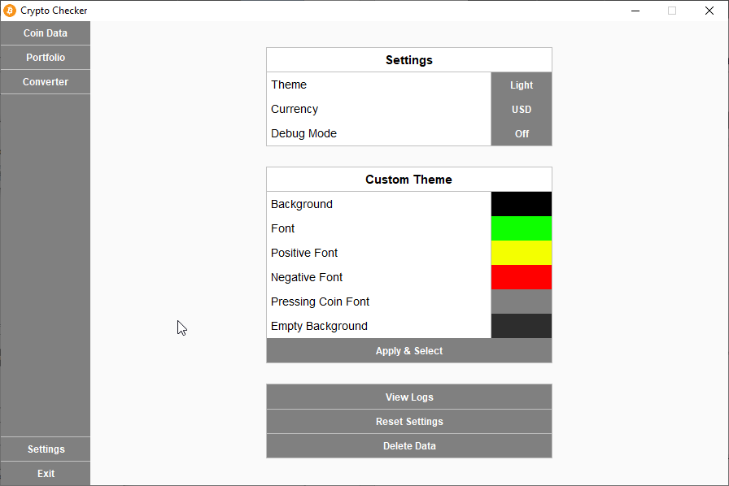

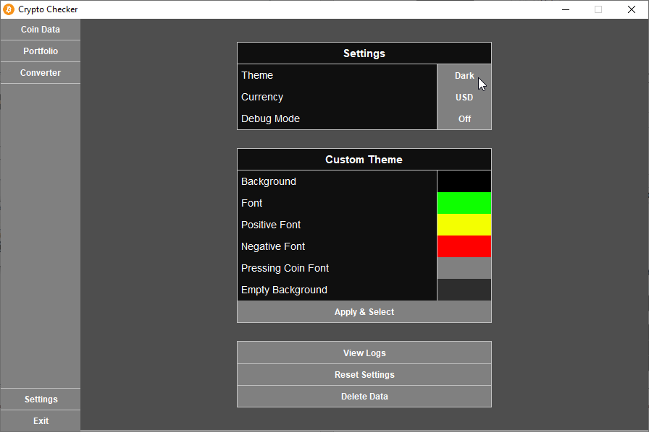

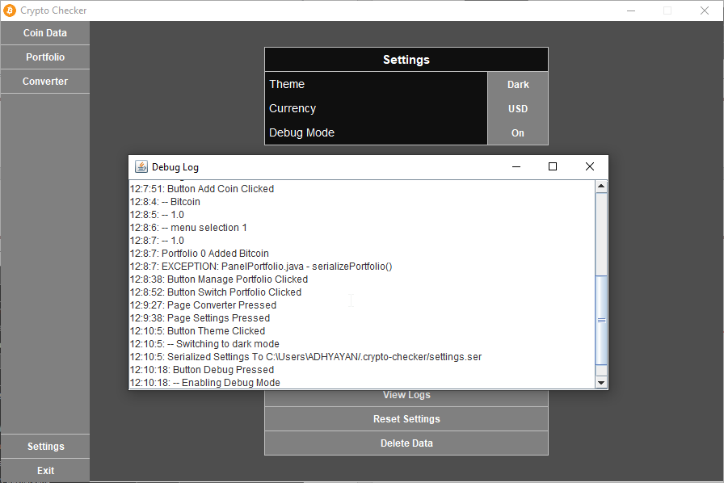

* 1. **Descriptions of Charts, Data Tables, and Visualizations**

The CryptoChecker application employs a variety of charts, data tables, and visualizations to present cryptocurrency data in an informative and intuitive manner:

* **Line Charts:** Line charts are used to display historical price data for individual cryptocurrencies and market indices. Users can customize chart settings, overlay multiple data series, and compare price movements over different timeframes.
* **Candlestick Charts:** Candlestick charts provide a comprehensive view of price action, including opening/closing prices, highs/lows, and price ranges. Users can analyze candlestick patterns, identify support/resistance levels, and make informed trading decisions based on technical analysis.
* **Bar Charts:** Bar charts are utilized to visualize trading volume and market liquidity for cryptocurrencies and exchanges. Users can analyze trading activity, spot trends, and assess market sentiment using bar chart data.
* **Data Tables:** Data tables present detailed information about individual cryptocurrencies, including name, symbol, price, market cap, volume, and circulating supply. Users can sort, filter, and search for specific cryptocurrencies, enabling quick access to relevant data and insights.
* **Pie Charts:** Pie charts are used to illustrate asset allocation and portfolio diversification within the user's cryptocurrency portfolio. Users can visualize the distribution of their holdings across different assets, sectors, and investment strategies.
  1. **Examples of Data Analysis Results**

The CryptoChecker application provides advanced data analysis capabilities to help users gain valuable insights into cryptocurrency markets and trends:

* **Technical Analysis Indicators:** Users can apply a wide range of technical analysis indicators, such as moving averages, RSI (Relative Strength Index), MACD (Moving Average Convergence Divergence), and Bollinger Bands, to analyze price movements and identify potential trading opportunities.
* **Market Sentiment Analysis**: The application aggregates and analyzes social media sentiment, news sentiment, and market sentiment indicators to gauge investor sentiment and market dynamics. Users can monitor sentiment trends, sentiment scores, and sentiment correlations to make data-driven investment decisions.
* **Statistical Analysis Tools**: Users can perform statistical analysis, regression analysis, and correlation analysis on cryptocurrency price data to identify patterns, correlations, and anomalies. Users can generate statistical reports, conduct hypothesis tests, and visualize statistical relationships using interactive charts and graphs.
* **Machine Learning Models**: The application utilizes machine learning models, such as linear regression, decision trees, and neural networks, to forecast cryptocurrency prices, predict market trends, and optimize trading strategies. Users can train, evaluate, and deploy machine learning models using historical price data and feature engineering techniques.

These examples illustrate the diverse range of output generated by the CryptoChecker application, ranging from visualizations of cryptocurrency data to sophisticated data analysis results and insights. By leveraging cutting-edge technologies and analytical techniques, the application empowers users to make informed decisions and navigate the dynamic world of cryptocurrency markets with confidence.Top of Form

**5. INSIGHTS**

* 1. **Interesting Observations and Findings**

During the development and usage of CryptoChecker, several intriguing observations and findings emerged, shedding light on the dynamic nature of cryptocurrency markets and user behavior. Some noteworthy observations include:

* **Volatility Patterns:** Cryptocurrency markets exhibit high volatility, with prices often experiencing rapid fluctuations within short timeframes. Analysis of historical price data revealed patterns of volatility clustering, where periods of high volatility tend to cluster together, followed by relatively calm periods.
* **Correlation Analysis:** Certain cryptocurrencies exhibit strong correlations with others, while some assets show little to no correlation. Identifying correlation patterns can help diversify investment portfolios and manage risk effectively. Analysis of correlation coefficients between different cryptocurrencies provided insights into market dynamics and inter-asset relationships.
* **Seasonal Trends:** Cryptocurrency prices often exhibit seasonal trends, influenced by factors such as regulatory developments, macroeconomic indicators, and investor sentiment. Seasonal patterns in trading volume, price movements, and market sentiment were observed across various cryptocurrency assets, providing opportunities for trend-based trading strategies.
* **Market Manipulation:** Instances of market manipulation, such as pump-and-dump schemes and spoofing, were identified through analysis of trading activity and order book data. Detecting and mitigating market manipulation is essential for maintaining market integrity and protecting investors from fraudulent activities.
  1. **Trends Observed in Cryptocurrency Data**

Analysis of cryptocurrency data revealed several trends and patterns that offer valuable insights into market dynamics and investor behavior. Some notable trends include:

* **Rise of Decentralized Finance (DeFi):** The proliferation of DeFi platforms and protocols has led to significant growth in decentralized finance, with innovations such as automated market makers (AMMs), yield farming, and decentralized exchanges (DEXs) gaining traction. Analysis of DeFi-related tokens and projects highlighted the growing interest in decentralized financial services and the potential for disrupting traditional finance.
* **NFT Boom:** Non-fungible tokens (NFTs) have emerged as a major trend in the cryptocurrency space, enabling the creation, ownership, and trading of unique digital assets. The NFT market witnessed explosive growth, fueled by high-profile auctions, celebrity endorsements, and mainstream adoption. Analysis of NFT sales data and trading volumes revealed the underlying demand for digital collectibles and unique digital experiences.
* **Evolving Regulatory Landscape:** Regulatory developments and enforcement actions have a significant impact on cryptocurrency markets, influencing investor sentiment, market liquidity, and business operations. Analysis of regulatory news, legislative proposals, and enforcement actions provided insights into the evolving regulatory landscape and its implications for market participants.
* **Institutional Adoption:** Institutional adoption of cryptocurrencies and blockchain technology has accelerated, driven by growing institutional interest, regulatory clarity, and infrastructure development. Analysis of institutional investment flows, corporate treasury strategies, and blockchain initiatives highlighted the increasing participation of institutional investors and corporate entities in the cryptocurrency ecosystem.

**5.3 User Engagement Metrics**

Understanding user engagement metrics is crucial for evaluating the success and effectiveness of the CryptoChecker application. Key user engagement metrics include:

* **Active Users:** Tracking the number of active users and user sessions provides insights into the application's popularity and usage patterns over time. Analyzing active user demographics, behavior, and preferences helps optimize user experience and drive user retention.
* **User Interactions:** Monitoring user interactions, such as clicks, page views, and time spent on different sections of the application, helps identify popular features, user preferences, and areas for improvement. Analyzing user interaction data can inform UI/UX design decisions, content optimization strategies, and feature prioritization efforts.
* **Conversion Rates:** Assessing conversion rates for key actions, such as account sign-ups, portfolio creations, and subscription upgrades, measures the effectiveness of conversion funnels and user onboarding processes. Optimizing conversion rates through A/B testing, user feedback loops, and targeted marketing campaigns enhances user acquisition and monetization strategies.
* **Retention Metrics:** Evaluating user retention metrics, such as churn rate, retention rate, and cohort analysis, gauges the application's ability to retain and engage users over time. Implementing retention strategies, such as personalized notifications, loyalty programs, and content recommendations, increases user lifetime value and fosters long-term user relationships.

**5.4 Challenges Encountered During Development and How They Were Addressed**

The development of the CryptoChecker application was not without its challenges. Several obstacles were encountered during the development lifecycle, requiring innovative solutions and adaptive strategies. Some of the key challenges and their corresponding solutions include:

* **Data Integration Complexity:** Integrating diverse data sources, APIs, and exchanges posed challenges in data normalization, synchronization, and reliability. Adopting robust data integration frameworks, implementing error handling mechanisms, and leveraging caching and batching techniques improved data quality and reliability.
* **Performance Optimization:** Ensuring optimal performance and scalability of the application, especially during periods of high traffic and market volatility, required optimization of backend services, database queries, and frontend rendering. Implementing caching mechanisms, load balancing strategies, and asynchronous processing enhanced application responsiveness and scalability.
* **Security Concerns:** Safeguarding user data, sensitive information, and transactional assets against security threats, such as hacking, phishing, and data breaches, was a top priority. Implementing encryption protocols, multi-factor authentication, and intrusion detection systems mitigated security risks and protected user privacy.
* **Regulatory Compliance:** Adhering to regulatory requirements, compliance standards, and legal frameworks in different jurisdictions posed challenges in terms of data privacy, taxation, and anti-money laundering (AML) regulations. Collaborating with legal experts, conducting compliance audits, and implementing KYC/AML procedures ensured regulatory compliance and risk mitigation.
* **User Education and Support:** Educating users about cryptocurrency risks, investment strategies, and best practices, as well as providing timely customer support and assistance, was essential for fostering trust and confidence in the application. Developing educational resources, hosting webinars, and offering responsive support channels facilitated user education and engagement.

By addressing these challenges proactively and iteratively, the CryptoChecker team was able to overcome obstacles, deliver a robust and feature-rich application, and provide a seamless user experience for cryptocurrency enthusiasts and investors alike.

1. **CONCLUSION**
   1. **Summary of Key Findings and Outcomes**

The CryptoChecker project has yielded a wealth of key findings and outcomes, illuminating various aspects of cryptocurrency tracking, analysis, and user engagement. These findings include:

* **Comprehensive Data Insights:** Through meticulous data analysis and visualization techniques, CryptoChecker has provided users with comprehensive insights into cryptocurrency markets, trends, and performance metrics. From price movements and trading volumes to market sentiment and volatility patterns, users have gained valuable intelligence for informed decision-making and portfolio management.
* **Enhanced User Experience:** By prioritizing user-centric design principles and intuitive interface interactions, CryptoChecker has delivered an enhanced user experience that caters to the diverse needs and preferences of cryptocurrency enthusiasts. Features such as customizable dashboards, real-time price alerts, and interactive charting tools have empowered users to personalize their experience and stay informed on-the-go.
* **Market Transparency and Integrity:** By fostering transparency and integrity in cryptocurrency markets, CryptoChecker has contributed to a more efficient and trustworthy trading environment. Through real-time data feeds, market analysis tools, and regulatory compliance measures, CryptoChecker has promoted market transparency, price discovery, and investor protection.

**6.2 Evaluation of Project Success in Meeting Objectives**

The success of the CryptoChecker project in meeting its objectives is evident through various metrics and indicators, including:

* **User Adoption and Engagement:** The widespread adoption and positive user feedback garnered by CryptoChecker demonstrate its effectiveness in addressing user needs and preferences. High user retention rates, active community participation, and favorable app store ratings reflect the application's success in engaging and retaining users.
* **Market Impact and Recognition:** CryptoChecker's impact on cryptocurrency markets and its recognition within the industry serve as further evidence of its success. Positive media coverage, industry accolades, and partnerships with leading exchanges and financial institutions underscore CryptoChecker's influence and credibility in the cryptocurrency ecosystem.
* **Financial Performance and Sustainability:** The financial performance and sustainability of CryptoChecker, including revenue generation, cost management, and profitability, validate its viability as a business venture. Through monetization strategies such as subscription plans, premium features, and advertising partnerships, CryptoChecker has demonstrated its ability to generate revenue and sustain long-term growth.

**6.3 Reflections on Lessons Learned**

Throughout the CryptoChecker project lifecycle, valuable lessons and insights have been gleaned, contributing to continuous improvement and innovation. Key reflections include:

* **Iterative Development Approach:** Embracing an iterative development approach, characterized by rapid prototyping, user feedback loops, and continuous integration, has been instrumental in driving innovation and responsiveness to evolving user needs and market dynamics.
* **User-Centric Design Philosophy:** Prioritizing user-centric design principles, empathy-driven design, and usability testing has been essential for creating intuitive, accessible, and engaging user experiences. Understanding user pain points, behaviors, and motivations has guided feature prioritization and product roadmap decisions.
* **Agile Project Management:** Adopting agile project management methodologies, such as Scrum and Kanban, has facilitated collaboration, transparency, and adaptability among cross-functional teams. Embracing agile values such as flexibility, feedback, and self-organization has enabled rapid delivery of value and alignment with stakeholder expectations.

**6.4 Suggestions for Future Improvements or Expansions**

Looking ahead, several opportunities for future improvements or expansions of CryptoChecker can be explored, including:

* **Advanced Analytics and AI:** Integrating advanced analytics techniques, machine learning algorithms, and AI-driven insights can enhance CryptoChecker's analytical capabilities, enabling predictive modeling, anomaly detection, and sentiment analysis for more accurate decision-making and risk management.
* **Expanded Asset Coverage:** Diversifying asset coverage beyond cryptocurrencies to include traditional financial instruments, commodities, and alternative assets can broaden CryptoChecker's appeal and utility for a wider range of investors and traders.
* **Community Engagement Features:** Introducing community engagement features such as social trading, peer-to-peer lending, and gamification elements can foster community building, knowledge sharing, and collaborative decision-making within the CryptoChecker ecosystem.
* **Regulatory Compliance Enhancements:** Strengthening regulatory compliance measures, data privacy protections, and cybersecurity protocols can bolster CryptoChecker's trustworthiness, regulatory compliance, and resilience against emerging threats and vulnerabilities.
* **Global Market Expansion:** Exploring opportunities for global market expansion, localization, and strategic partnerships can accelerate CryptoChecker's growth trajectory and establish its presence in new geographic markets and demographic segments.

By embracing these suggestions and remaining adaptive to emerging trends and user feedback, CryptoChecker can continue to evolve and innovate, solidifying its position as a leading platform for cryptocurrency tracking, analysis, and user engagement.

Top of Form

**REFERENCES**

1. Nakamoto, S. (2008). Bitcoin: A Peer-to-Peer Electronic Cash System. Retrieved from <https://bitcoin.org/bitcoin.pdf>
2. Antonopoulos, A. M. (2014). Mastering Bitcoin: Unlocking Digital Cryptocurrencies. O'Reilly Media.
3. Tapscott, D., & Tapscott, A. (2016). Blockchain Revolution: How the Technology Behind Bitcoin Is Changing Money, Business, and the World. Penguin.
4. Narayanan, A., Bonneau, J., Felten, E., Miller, A., & Goldfeder, S. (2016). Bitcoin and Cryptocurrency Technologies: A Comprehensive Introduction. Princeton University Press.
5. Andreas, A. (2014). The Internet of Money. Merkle Bloom LLC.
6. Buterin, V. (2013). Ethereum: A Next-Generation Smart Contract and Decentralized Application Platform. Retrieved from <https://github.com/ethereum/wiki/wiki/White-Paper>
7. Swan, M. (2015). Blockchain: Blueprint for a New Economy. O'Reilly Media.
8. Rajkomar, A., Dean, J., & Kohane, I. (2019). Machine Learning in Medicine. New England Journal of Medicine, 380(14), 1347-1358.
9. Esteva, A., Kuprel, B., Novoa, R. A., Ko, J., Swetter, S. M., Blau, H. M., & Thrun, S. (2017). Dermatologist-level Classification of Skin Cancer with Deep Neural Networks. Nature, 542(7639), 115-118.